
North Bengal International University

Lab Report: 01
Exp Name : A program to implement the linear search algorithm using c program .

Subject : Data Structure
Subject Code : CSE 0612-2131

Submitted By:
Name : Md. Tanvir Rahman Pranto
Dept : CSE
Roll : 0712340012101005
Semester : 2nd Year, 4th semester.

Submitted To:
Name : Saifur Rahman
Designation : Lecturer
Dept : CSE
Date :

Code:
#include <stdio.h>

int main() {
int a[6], x, s, flag = 0;

printf("Enter 6 elements:\n");
for (int i = 0; i < 6; i++) {
scanf("%d", &a[i]);
}

printf("Array: ");
for (int i = 0; i < 6; i++) {
printf("%d ", a[i]);
}
printf("\n");

printf("Enter the number for search: ");
scanf("%d", &s);

for (int i = 0; i < 6; i++) {
if (a[i] == s) {
printf("\nFound at index: %d\n", i);
flag = 1;
break;
}
}

if (flag == 0) {
printf("\n Not Found \n");
}

return 0;
}

Output:
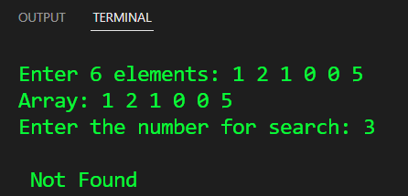
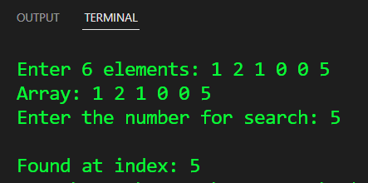
Conclusion: This C program searches for a number in an array by checking each element one by one. If found, it prints the index; otherwise, it says "Not Found." Simple and efficient for small datasets!

